

## Test Four

## Semester Two 2018 UNIT 2 METHODS

## Calculator Assumed 40 minutes /41 marks

## Scientific Calculator, ClassPad, Formula Sheet and One page one side of A4 notes is permitted

**Name:**

Place a tick in the box next to your Mathematics teachers name:

|  |  |
| --- | --- |
| **Mr Strain** | **□** |
| **Ms Sindel** | **□** |
| **Ms Rimando** | **□** |
| **Mr Gannon** | **□** |
| **Mr Young** | **□** |
| **Mrs Flynn** | **□** |
| **Ms Ensly** | **□** |
|  |  |

**Question 1 (1, 1 = 2 marks)**

A committee of two is to be chosen from a class of 20 students, 12 boys and 8 girls

1. How many different committees could be chosen?
2. How many committees if both students are girls?

**Question 2 (1, 1, 1 = 3 marks)**

Six students, three boys and three girls, are to be seated in a row of six seats.

Find the number of ways in which they can be seated:

1. if there are no restrictions
2. if the boys must sit together and the girls must sit together
3. if the boys must sit together.

**Question 3 (1, 1, 3 = 5 marks)**

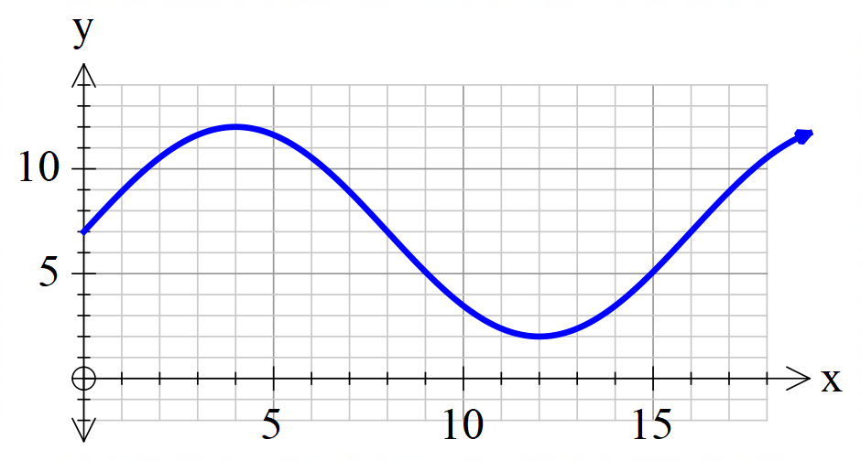Consider the graph below

i) State the amplitude of the graph.

ii) State the period of the graph

iii) Write an equation that will result in the graph.

**Question 4 (2, 2 =4 marks)**

a) Simplify into index form.

$3^{3x+10} ÷{ 15}^{4x-6}$

b) Solve

$\sqrt{2}\cos{2x-1=0}$ for $-2π ≤x ≤0$

**Question 5 (4 marks)**

If $\sin\left(x\right)=\frac{3}{5} and\cos\left(y\right)=\frac{5}{13},$ where $x$ is in the second quadrant and $y$ in the fourth, find the exact value of $\sin\left(x-y\right).$

**Question 6 (4, 2 = 6 marks)**

Shown below are the graphs of

$f\left(x\right)=\tan\left(ax+b\right)and h\left(x\right)=ecos \left(x+f\right)$ where *x* is in radians.

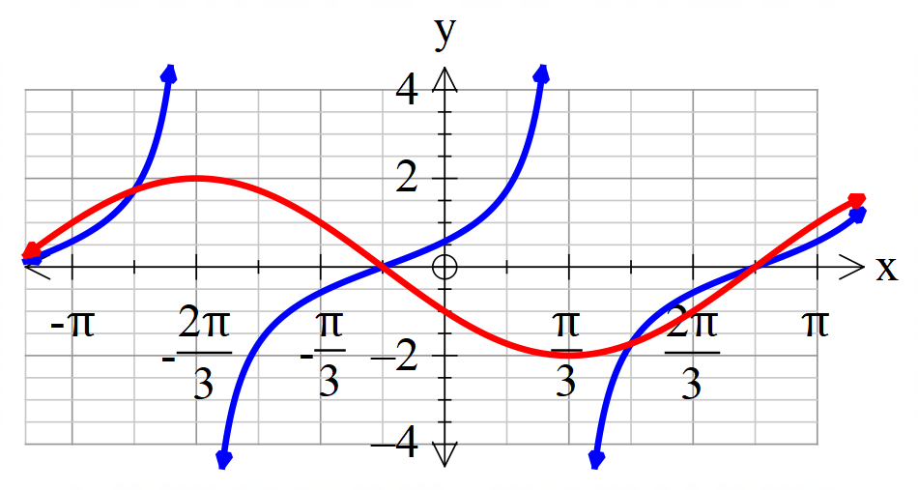

1. Determine the values of the constants $a,b, e and f$.
2. Use the graph to solve $f\left(x\right)=h\left(x\right), -π≤x≤π.$

**Question 7 (2, 2, 1, 3 = 8 marks)**

Consider quadrilateral ABCD, with diagonal BD dividing the quadrilateral into two acute-angled triangles.



a) Calculate the length of the diagonal BD.

b) Give the possible sizes of angle C.

c) Why must one of the angles be discarded?

d) Calculate the area of quadrilateral ABCD.

**Question 8 (1, 1, 2 = 4 marks)**

The graph below shows the number of assaults in a particular suburb since 1980.

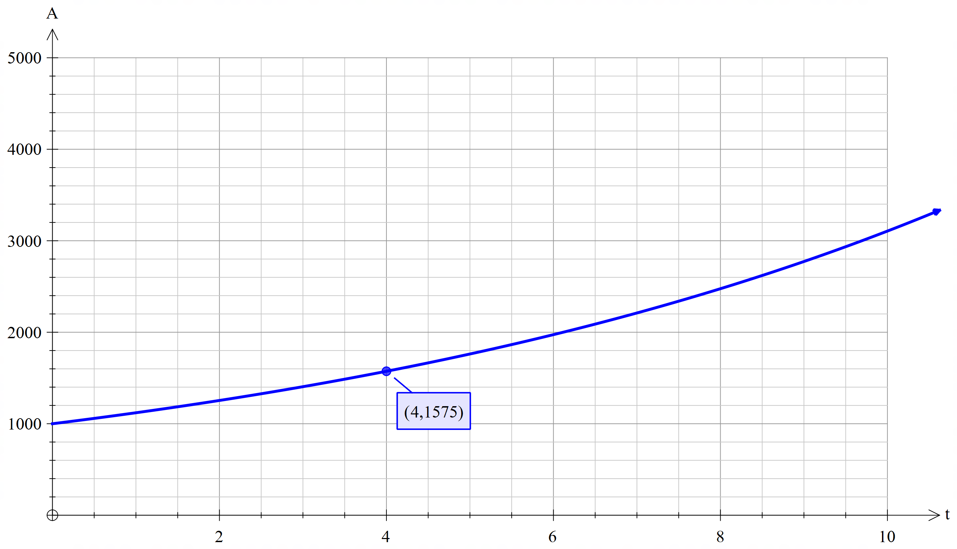

1. Find an exponential model for the number of assaults each year where t is the time since 1980.
2. Assuming there was no intervention set up for this suburb, how many assaults would be predicted for 2020?
3. When will the assault level have increased 100-fold?

**Question 9 (5 marks)**

Two circles with radii 25cm and 20cm have their centres 30 cm apart. Determine the size of the common area to both circles correct to nearest square centimetre.

End of test